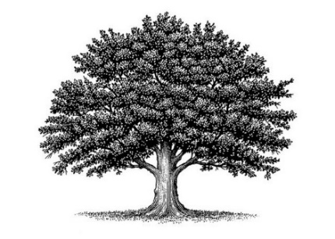
Deed of Land Recording #RF000 000 000 000(Reg Mail Number)
American Common Law Copyright and Trademark of Trade Name
First Middle Last

On the ___ day of __________ in the year ________ Anno Domini at the hour and minute of _________ a.m./p.m., a new baby was born on the land of _________________ County in the _____________________State to the __________________Family and was given the name: _______________________________________.

The private natural biological parents are: __________________________________, Father, born ___________on the land of the ________________________County in the ___________________State or foreign country:_____________________& _______________________________, Mother, born
___________on the land of the ______________________County in the ___________________State or foreign country:_________________________.

The family lives in the ________________________County of the ____________________State near ____________________________ and keeps the mailing address: __________________________
___________________________________________________________________________________.

This baby is their ________ living child and ______________ son or daughter (please circle one).

Witness:___________________________________________________________

Recording Secretary and International Notarial Witness Jurat
Michigan
Jackson County

I, ______________________________, a Recording Secretary and International Notarial Witness, approved by The Michigan Assembly, do hereby affirm that the Witness has been positively identified and I have witnessed their signing of this Deed of Land Recording on this ________ day of ____________ in the year _______.

Michigan Assembly Recording Secretary _________________________________________________

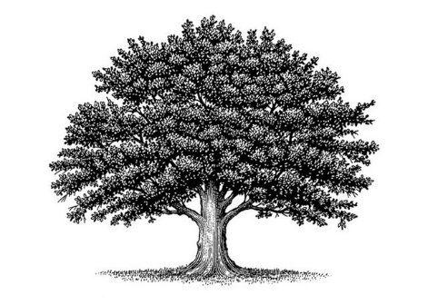
[EXAMPLE OF HOW A FINISHED BABY DEED LOOKS – except for autographs and witness block]
Deed of Land Recording: RA 360 124 200 US
American Common Law Copyright
and Trademark of Trade Name
Genevieve Clementine Martin
On the 20th day of June in the year 2021 Anno Domini at the hour and minute of 10:05 a.m., a new baby was born on the land of Jackson County in the Wisconsin State to the Martin Family and was given the name: Genevieve Clementine Martin.

The private natural biological parents are: Scott LeBrand Martin, Father, born November 6, 1985, on the land of the Wahatchee County in the Idaho State & Jeanine Lucille (Morgan) Martin, Mother, born April 6, 1990, on the land of the Hillsboro County in the Maine State.

The family lives in the Jackson County of the Wisconsin State near Black River Falls, Wisconsin, and keeps the mailing address: c/o 17789 Highway 12, Black River Falls, Wisconsin, 54615.
.
This baby is their second living child and first daughter.

